Programme/Project Number: 00096449  Programme/Project Title:  Elimination of Violence against Women and Gender-based Violence in St Helena  Implementing Partner:  Children and Adult Social Care Directorate of St Helena  Project Progress Report  2019 | 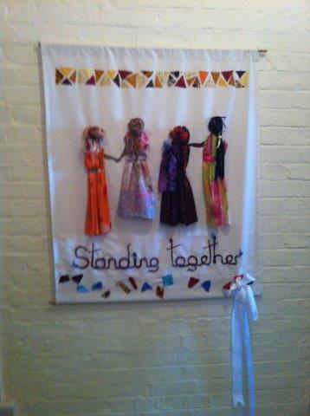

Report Compiled by: Nicolene Adams
Project Manager

January- December 2019

Signed by: Tracy Poole – Nandy 
Director: Children and Adult Social Care
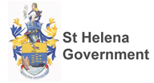

Contents
- Acknowledgements
- Progress of Project – Major Achievement
- Achievements – Children and Adult Social Care
- 2019 Updated Risk Log
- Reviewed Sustainability plan
- Current Situation – Proposal 2020 funding
- AWP – 2020
- Police 2019 Statistics

Acknowledgements
The Government of St Helena and Safeguarding Directorate wish to sincerely thank the United Nations Development Programme for the extensive financial, administrative and strategic support for the past 5 years. The support and guidance that has been graciously provided to St Helena has resulted in the establishment of a Safe Haven Shelter for women escaping abusive relationships. Women on the island can now access intervention support programmes as admission or outreach clients. This year the UNDP funding was focused on securing the environment and developing a safe area for the disabled clients on St Helena. We wish to sincerely thank and acknowledge the work of Petra Valastinova (Ms.) UNDP Programme and Operations Associate and UNDP Project Board members who have continually provided guidance and support during the role out and establishment of the project. The St Helena Government has committed to the project by taking ownership of funding new policies, expenses linked to transitioning from care to independent living facilities, staff salaries and the day to day running of the Safe Haven. SHG is committed to funding the project annually to ensure the continual and efficient running of the service, this is commitment is based upon continued funding support from DfID which is reviewed on a yearly basis.
PROGRESS REPORT FOR 2019 against AWP Outputs - Major Achievements
OUTPUT 1: A SPECIALIST SAFE HAVEN FACILITY CREATED FOR ST HELENA
The purpose of the first output of project is the provision of safe and secure accommodation and support for women, with or without children, who need to leave their home as a result of domestic abuse. The expected outcome of this output is that women and children with disabilities can access specialist support services in a safe and accommodating environment.
Activity 1: Refurbishment and adaptions of the available bedrooms, kitchen and bathroom for disabled
Targets: Renovation and adaptation of the safe haven for disabled clients.
The first phase of the refurbishment was to build the new disabled bathroom on the existing safe haven. Through the tender process, Mr Alwin Yon, an independent local contractor has been selected. The work of installing a disabled wet room, refurbishing a bedroom and kitchen area started in July and has subsequently been completed. The contractor built the level access bathroom to the side of the existing Safe Haven property, refurbished and redesigned the available dining room into a disabled bedroom and successful structured the kitchen area for wheel chair access to promote independence in all these living areas. Photographic evidence of achieved activities in line with the AWP output 1 is attached as Annex 2 to this progress report. Using the services of an independent project manager, hired by the St. Helena Government, contributed to the smooth running of the job tender process to secure the services of the contractor. Oversight of the works and updates on progress of bathroom, bedroom and kitchen areas were provided by the project manager on a regular basis. We have learnt that when the project outputs are linked to refurbishment that an independent professional building contractor is a valuable resource to use to ensure the regular oversight of the project that monitors progress and ensures accountability. The refurbishment and contracts for services budget lines have been overspent as the invoices from contractor also included some materials and furniture originally budgeted separately. The employment of a project manager to mitigate the risks that were experienced with planning of this activity since 2019, as well as all other costs related to refurbishment that have exceeded the budget allocation for this activity was covered by SHG in line with their commitment and sustainability plan for 2019.
Activity 2: Furnishing and setting up areas for functional living
The expected outcome of this output was to set up suitable living areas for disabled clients with appropriate furnishings. The overall aim a suitable safe environment that enables all clients to access to specialist support services
Target: Safe Haven is fully equipped for people with disabilities
Specialist and disability furnishings and equipment for all installed and refurbished areas have been procured and installed. A portion of building materials and other stock had to be procured from overseas, these were ordered well in time to ensure timeframes for completion of this project output was achieved.
Activity 3: Development and Maintenance of grounds and environment
Our aim was to create a garden area to help promote self-care by encouraging activities like planting, weeding and watering that can be therapeutic for families experiencing trauma. As a service we envisage parents and children residing in the Safe Haven spending fun, quality time working together in the garden. Activities like planting, weeding and watering can be therapeutic and recreational for children who have endured trauma. Horticulture programs can also serve as a childcare function, creating activities for children while parents attend counselling or search for jobs and affordable housing.

Targets:

- Development and maintenance of grounds and environments
- Developing and set up of Herb and Vegetable garden for Shelter

In Q1 of the year the surrounding ground area of the Safe Haven had been cleared in preparation for the development of the herb and vegetable garden as set out in the AWP 2019. St Helena’s water situation remains serious and, despite recent spells of rainfall, surface flows have not increased and stored water levels remain very low. Stored water volume subsequently continues to decrease and as a result of this we envisage that further Island-wide water restrictions will be imposed. With St Helena nearing the holiday period, and with warm weather patterns and no significant rainfall forecast all gardening projects have been suspended during this time as water can be for essential consumption use only.
https://www.sainthelena.gov.sh/2019/11/st-helena-water-situation-remains-critical/
We requested that the funding linked to this output be reassigned to be used in Output 2 Activity 4.
OUTPUT 2 – EXPAND SERVICE PROVISION
Activity 4: Domestic Violence Awareness raising campaigns
The purpose of the Domestic Violence service is to improve local responses and expand service provision to domestic violence against women by raising awareness through campaigns on the Island of St Helena. “Internationally recognised days are occasions to educate the public on issues of concern and to mobilise political will and resources to address global problems, and to celebrate and reinforce achievements of humanity and more4 importantly the service users and services of our Island.
Target:
- Organise and 3 public events attended for awareness raising, one event in line UN International DV day 2019.
- Create 3 awareness raising leaflets according to international themes for 2019 Domestic Violence.
Event 1. WEAAD – World Elder Abuse Awareness Day 15 June 2019.
The international theme for WEEAD 2019 was “Lifting up Voices”. This theme served as a platform for unifying Elder Justice and Violence against Women by sharing the lived experiences of older people of St Helena. Our aim was to raise awareness and lift up the voices of our elderly. The target of the event was to improve local responses and expand service provision by raising awareness through campaigns. Further to this, as a Directorate we had the privilege of hosting Community and Residential Elderly Persons Tea Parties for residents of different districts across the island from Monday the 24th of June to Friday the 28th of June. This campaign focussed on the overall protection for the elderly on St Helena resulting in the service addressing institutionalisation and neglect of care in our Elderly residential and sheltered accommodation settings. The Public Guardian continues to work with court appointed Deputies who make decisions in relation to a person’s property and financial affairs and/or a person’s personal welfare.
Event 2 - IYD and CROC – International Youth Day and 30th Anniversary of the Convention on the Rights of the Child
The recognition of the United Nations International Youth Day, the Children & Adults Social Care Directorate’s Safe Haven Project hosted a special event to celebrate young people on St Helena at the Mule Yard, Jamestown on Friday, 13 September 2019. To recognise the 30th anniversary of the adoption of the United Nations (UN) ‘Convention on the Rights of the Child’, a number of School assemblies was held on Wednesday, 20 November 2019. The overall message of the campaign was to highlight the rights of learners to be thrive and develop in school free from bullying and cyberbullying and intimidation. While targeting other audiences, as well, the event particularly focused on highlight grooming of young girls 15 – 17 by older males that is a current concern on the island. St Helena has underpinning legislation which promotes the safety and wellbeing of children on the Island by means of the Welfare of Children Ordinance. The Children and Adult Safeguarding Board offers scrutiny in relation to the multi-agency approach to the safeguarding of children and vulnerable adults on St Helena. This established forum ensures that children are and will be protected from harm and abuse from a multi-agency perspective. In the 2015 WASS enquiry the report highlighted the lack of joint up services working together to mitigate risks and the lack of understanding on island of children rights. The corporate parenting strategy was successfully delivered on St Helena in July 2019 ensuring that all looked after children here on St Helena receive adequate parenting in the care of the St Helena government. As SHG employees we were starkly reminded that we have the responsibility as corporate parents to protect and care for our looked after children. The Children and Adults social care has also successfully delivered a fostering campaign as a directorate we are proud to announce that the campaign resulted in the recruitment of two foster families on St Helena. The launch of the Youth Parliament in November 2019 was an excellent stride to ensuring the rights and indeed the voices of children are heard on St Helena.
Event 3 – WR – White Ribbon Campaign
Monday, 25 November was the United Nations (UN) White Ribbon Day 2019. The day was used to raise awareness about all types of abuse. On St Helena, the UN Development Programme Safe Haven Project and the Children & Adults Social Care Directorate ran a week-long awareness raising campaign to recognise White Ribbon Day 2019. Around the world, White Ribbon awareness focusses on men taking a stand against domestic violence. The White Ribbon Day Committee chose to change the focus from targeting males and decided that the aim and vision would be to use the voices of the male and female population of St Helena to encourage all on the Island to ‘Speak Out and Stand Up’ against all kinds of abuse, irrespective of gender and age. The Campaign concluded with a peaceful march from Napoleon Street to the Castle Gardens for a closing ceremony. A rose bush was also planted and a plaque laid in the Castle Gardens in honour of survivors and victims of domestic abuse. This campaign highlighted the impact of abuse on children and adults in St Helena. Multi-agencies worked together collaboratively and cohesively to ensure the successful delivering of campaigns, to improve our local response as public services.
More information can be found on the St Government website and at the following web addresses.
https://www.facebook.com/StHelenaGovt/
https://twitter.com/StHelenaGovt

Achievements– Children and Adult Social Care Directorate St Helena Government
- Employing and reinvigorating the post of Safe Haven Lead to qualify as an IDVA (Independent Domestic Violence Advocate). The Safe Haven Lead is a member of the police MARAC, MAPPA meetings. The role also requires the Lead to support residents and outreach clients, to oversee the daily running of the Safe Haven Services.
- Safe Haven Admission and Discharge Budget SHG. We have had 3 families successfully transition from the Safe Haven back into community and independent living. It is evident that survivors suffer financially both short and long term. When a family has to go into social housing they have furnish and equip a house that is supplied only with a bathroom and a kitchen with a sink. As a Directorate we have had to using funding linked to our (Child in need) budget to help families settle in their new homes. One of our responsibilities of a service is to ensure the safe transitioning of service users from care into community living. Helping the family unit of mother and children set up their homes and the lives forms part of the Discharge Policies for the Safe Haven.
- International Disability Day – International Day for Persons with Disabilities (IDPWD) is recognised each year on 3 December, and is a day used to promote an understanding of disability issues and mobilise support for the dignity, rights and wellbeing of persons with disabilities. This year’s theme was ‘The Future is Accessible’ - meaning we must all, together, look toward a future where the barriers that stand in people's way no longer exist. In recognition of IDPWD, St Helena’s Active Participation in Enterprise (SHAPE), supported by the Children & Adults Social Care Directorate, organised a parade through Jamestown to celebrate and raise awareness of disability. Participants were dressed in and vehicles decorated in blue and orange. The colour blue symbolises support for the dignity, rights and wellbeing of people with disability, and orange symbolises the inclusion of people with disability in all aspects of political, social, economic and cultural life. During this campaign we had the opportunity to highlight one of the Priorities of SHG 2020-2023 Strategy “Altogether Safer” This priority focuses on keeping our vulnerable safe from crime. Disorder and danger which includes domestic violence and violence against women.
- Policy for Work experience Placement Providers. The Policy has been created to assist the St Helena Education Community College in keeping young people on Work Experience placements safe from exploitation and inappropriate contact.
- St Helena Government Exploitation Prevention and Response Policy for children under the age of 18 years old. The St Helena Safeguarding Board (SHSB) Multi-Agency Child Exploitation (MACE) Screening Tool can be used by any professional who has concerns that a child may be at risk of either sexual or criminal exploitation.
- Strategic MACE - The key purpose of the Strategic MACE will be to provide a detailed overview of the profile of Child Exploitation within St Helena. This includes emerging concerns about particular localities, addresses, businesses or professions. The Child Exploitation Screening Tool is discussed at ALL Multi Agency Child Exploitation Meetings (Weekly MACE) where it is reviewed alongside other information and intelligence and a risk category is assigned.
- The Multi-Agency Risk Assessment Conference (MARAC) process which is a local multi-agency meeting led by the Police Directorate and Probationary Services which is aimed at protecting victims of domestic abuse, stalking and ‘honour’ based violence through a range of multi-agency interventions., sexual orientation, gender or gender identity.
- The MARAC aims to: Share information to increase the safety, health and well-being of victims/survivors, adults and their children. Determine whether the alleged perpetrator poses a significant risk to any particular individual or to the general community.
- Training -The St Helena Community College (SHCC) provides an e-learning module: Safeguarding Children from Abuse by Sexual Exploitation which is designed to improved awareness. The SHSB recommends that all agencies make the e-learning module mandatory for all staff who come into contact with children and young people.
Professionals have already completed the CSE e-learning and have also attended the two-day inter-agency Safeguarding Children, Young People and Vulnerable Adults and the specific Exploitation prevention and response training that will be available under the umbrella of the Safeguarding Board from February 2020.
- Safeguarding Training (Police and Health). Both the staff of the Police and Health Directorates have attended updated Safeguarding Training delivered by Social Services and Police. The training Safeguarding Children from Abuse by Sexual Exploitation which is designed to improved awareness. There are plans to expand the training to all other government sectors.
Budget, expenditures, delivery
The table below summarizes project expenditures as of October 2019. The delivery only reached 62%, however, is expected to pick up in the last two months of 2019 when the final payments for refurbishment and awareness raising activities will be processed. The overall delivery is expected to reach 90-95%.
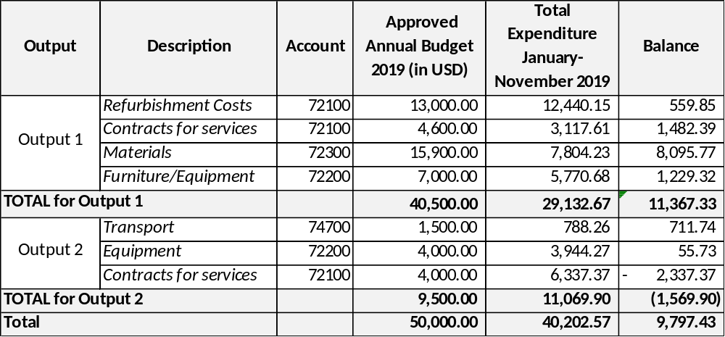
As a result of savings on Activity 3 (Output 1) related to Establishment of Herbs and Vegetable Garden which could not be implemented due to weather conditions on the Island, the Children and Social Care Directorate (formerly known as Safeguarding Directorate) would like to request re-allocation of unspent balances from budget lines 72200 and 72300 under Output 1 in the total amount of USD 1,950 and the remaining balance on budget line 74700 (Transport) under Output 2 in the amount of USD 760 to budget line 72100 under Output 2 (Activity 4- Domestic Violence Awareness raising campaigns). The justification for the increased costs related to the awareness raising campaigns relates to the fact that in 2019, the aim of SHG was to involve the whole community of St Helena. As a result, the costs of the resources to run a week- long White Ribbon campaign exceeded the proposed funds initially allocated. In addition, we would like to request approval of re-allocation of unspent budget from accounts 72300 and 72200 in the amount of USD 5,500 under Output 1 to budget account 72100 due to increased costs under Output 1 (Refurbishment), account 72100. The increased costs under Refurbishment were due to the contract type signed with the contractor, where most of the furniture and materials were already included and thus charged to the same account as refurbishment costs.

Project Title: Elimination of Violence against Women and Gender-based Violence in St. Helena
Updated Risk Log – December 2019
Report Compiled: Project Manger
Project Title: Elimination of Violence Against Women and Gender-based Violence in St Helena | Award ID: 00096449 | Date: December 2019
Updated risks

Description | Date Identified | Type | Impact &  Probability | Countermeasures / Mngt response | Owner | Submitted, updated by | Last Update | Status
- Shortage of onshore materials for construction. Delay in receiving materials due to shipping timeframes. | July 2019 | Operational | P – 3  I -3 | Working with SHG Procurement services to secure efficient ordering and purchasing of materials within the required timeframes | SHG | Nicolene Adams | December 2019 | All materials procured in advance to avoid delays in project implementation. Working with SHG Procurement services proved efficient in addressing shortage of materials on the island.
- Delay in timely submission of reports | July 2019 | Operational and Strategic | P- 3  I - 3 | Closer working with new Finance Team and New Safe Manager to manage project and account for events | SHG | Nicolene Adams | December 2019 | Secured, in cooperation with the SHG finance team, the timeliness of the reporting improved.

Sustainability Plan 2020

The Sustainability Plan is based on the lessons learned during the 2016 – 2019 period and evidence based on program evaluation that informs continuous quality improvement of the service since the opening of the Safe Haven in July 2016. This plan is a working document that will be updated as needed however, it is responsive to the current Sustainability Plan and specifically to the achievements of the Outputs and targets set out in the UN Project Document for the year 2020.
St Helena Government is still committed to co-financing the Domestic Violence Project for a 3-year period since January 2018. Provision has been granted and made in the Children and Adult Social Care Directorate 2020 budget to fund the monthly running costs of the Safe Haven, maintenance of residence, staff salaries, local staff training and financial support to families transitioning from the Safe Haven to the community homes. The Safe Haven project is an important facility and was designed to create a safe home and provide support services to women who are forced to leave their homes due to domestic abuse or for women who require outreach support, but it alone cannot resolve the problems experienced by victims of domestic abuse. For the long term, victims need to be able to return to their homes or to establish new homes for themselves and their children where they can live independent lives free from any further abuse. Professionals have already completed the CSE e-learning and have also attended the two day inter-agency Safeguarding Children, Young People and Vulnerable Adults and the specific Exploitation prevention and response training that will be available under the umbrella of the Safeguarding Board from February 2020.The supporting structure for staff and the effective operation of the service will be the newly drafted bespoke Children and Adult Social Work Practice Standards, Code of Practice 2018 which is to be reviewed January 2020. The Domestic Abuse Bill provides protection for the victims of domestic abuse and their children. The provisions of the bill will define the types of behaviour that constitute domestic abuse and will enable a person who is the victim of such behaviour to make an application to the court for a protection order. The application can also be made by another person (such as a police officer or social worker) or on behalf of a child who is affected by the abuse. Breaking the order results in the person whom the order is held against to be held in contempt of court against civil action.
The production of Domestic Abuse Policy is a proposal for new legislation
As a service our strategic plan aims to fill critical gaps in the community’s response to domestic violence; strengthen and deepen our impact as an organization that has experienced tremendous growth in recent years. It is envisaged to enhance our programs’ accessibility to varied vulnerable populations, to review multi-agencies working together procedures and policies and invest in infrastructure. The goals laid out in this plan will allow the Safe Haven Domestic services the opportunity to further its mission by meeting the safety needs of victims, while also participating in transformative change that will better equip our community to respond to domestic violence.

Saint Helena Government Safeguarding Directorate PROPOSAL FOR FUNDING 2020
Proposed Work plan for 2020 builds on the 2019 workplan and includes activities that were planned but not completed in 2019. In addition, the 2020 proposes additional activities aiming at improvement of services provided by the Safe Haven and increasing awareness of general public on domestic violence.
Background
Although as a community, St Helena is small, isolated and remote, the similarities of global issues remain the same. For example, domestic abuse and gender-based Violence is a significant issue in the same way as it is in most other countries. Anecdotal evidence points to increased prosecutions and an increased level of support from St Helena Government Directorates in partnership with civil society. One of our current Legislations is the Domestic abuse bill (Protection Orders) in effect holding perpetrators civilly liable. The following statistics are based on Domestic Abuse Protection Orders – Court cases (Jan 2019 – Nov 2019):
May 2019 – 6 Months – Following conviction assault
June 2019 – 18 Months – Following conviction assault
Oct 2019 – 12 Months – Assault withdrawn, DAPO as alternative
We have seen an improvement in working together between Children and Adult Social Care Service, Police. Probationary services and the Human Rights commission. In the Equality & Human Rights Commission Interim Report 2019 the issues the EHRC is dealing with are becoming more profound. They include the need to introduce local Ordinance protecting those in the private and public sphere from discrimination, sexual harassment and bullying. Statistics show that in this period 2 clients sought support from the EHRS regarding domestic abuse.
Our current legislation does not adequately protect the survivors of domestic abuse. The bill we do have falls short of the UN guidelines. There is a lack of protection from sexual harassment, coercive and controlling behaviour, grooming and bullying in the public and private sector. We will be proposing the development and the introduction of a Domestic Abuse Bill for 2020.
The aims of the proposed domestic abuse bill include:
- Enshrine a definition of domestic abuse in law;
- Recognise the harm domestic abuse inflicts on a child;
- Furthering both the Government’s domestic abuse strategy and its Violence against Women and Girls (VAWG) strategy.
- Provision of measures which will help all victims of domestic abuse including women and men, and victims within LGBT and wider family relationships.
- Recognition of the gender inequality underlying domestic abuse, and the need to reflect this inequality in education programmes, funding, service provision, criminal justice and other statutory responses to domestic abuse.
- Recognise that domestic abuse applies irrespective of gender or age, but that the disproportionate impact of domestic abuse on women and girls is explicitly highlighted in the text of the bill and the statutory guidance.
The main aim is to prevent domestic abuse “by challenging the acceptability of abuse and addressing the underlying attitudes and norms that perpetuate Violence against Women and Girls (VAWG) and all related offences.
Safe Haven Services have transitioned 3 families back into independent living. Each of the families consisting of Mother and Children. While the Safe Haven is well resourced the family usually come into care with the basics of clothing needed. The SHG Children and Adult social care Directorate had to provide financial assistance to families to meet their needs on admission and prior to discharge when a home is needed to be prepared. Based on the feedback from service users, we accept that shelter life presents them with both opportunities and risks. Challenges are discussed related to service provision, the built environment, resources, staffing, gaps in the knowledge base and child friendly spaces to build dignity, improves skills and develop educational needs. A new Policy and Procedure Manager has been appointed in our directorate, she is currently updating and drafting new policies and procedures which include the Domestic abuse policies that might mitigate challenges. The newly appointed Safe Lead and IDVA (Independent Domestic Violence Advocate after being trained will be required to train other support services and will be clear on her role as IDVA. The main purpose of independent domestic violence advisors (IDVA) after being trained will be required to train other support services and will be clear on her role as IDVA.

The main purpose of independent domestic Violence advisors (IDVA) is to address the safety of victims at high risk of harm from intimate partners, ex-partners or family members to secure their safety and the safety of their children. Serving as a victim’s primary point of contact, IDVA’s normally work with their clients from the point of crisis to assess the level of risk, discuss the range of suitable options and develop safety plans. They are pro-active in implementing the plans, which address immediate safety, including practical steps to protect themselves and their children, as well as longer-term solutions. These plans will include actions from the MARAC as well as sanctions and remedies available through the criminal and civil courts, housing options and services available through other organisations. IDVAs support and work over the short- to medium-term to put them on the path to long-term safety. SHG remain committed to co-financing training for staff.

For the above service to be effectual and efficient the newly appointed IDVA must receive specialist accredited training and hold a nationally recognised qualification. Since they work with the highest risk cases, IDVAs are most effective as part of an IDVA service and within a multi-agency framework. The IDVA’s role in all multi-agency settings is to keep the client’s perspective and safety at the centre of proceedings. Studies have shown that when high risk clients engage with an IDVA, there are clear and measurable improvements in safety, including a reduction in the escalation and severity of abuse and a reduction or even cessation in repeat incidents of abuse.

The UN has previously invested in training, we as a Directorate have learnt that is more beneficial to train and upskill native Islanders whose permanent home is ST Helena. Our new Safe Haven Lead / IDVA will benefit from exposure training outside of ST Helena. We have no other service on ST Helena where the incumbent can study, develop and learn through observation and practical exposure.

With thanks to the United Nations Development fund as a Directorate we have hosted 4 successful DV awareness raising against women and girls, children, the elderly vulnerable people abuse. Without funding there will be shortage of awareness raising campaigns resulting in minimal awareness raising campaigns as SHG needs to fund all campaigns linked to all directorate raising public awareness involves creating a specific messaging campaign about a particular issue. Awareness is an important part of developing the St Helenian community support for changes in the informal justice sector, it has been shown to change knowledge and attitudes about violence against women and girls, children of all ages and irrespective of genders.

Next Steps - Based on the Risk Log 2019, Reviewed Sustainability plan 2020 and lessons learnt, funding for the following activities are being recommended for the period of 2019 – 2020.
Annual Work Plan – AWP 2020

OUTPUT 1 – CREATE A SPECIALIST SAFE HAVEN FACILITY FOR ST HELENA
Currently, there are no structured resources for skill development and to support confidence building for children of families in garden area. The first output of the project will support provision of safe, secure refuge accommodation which will be accessible to women both able- bodied and disabled, with or without children, who need to flee their home as a result of domestic abuse. The building and equipment are currently owned by the St Helena Government’s Safeguarding Directorate. The Manager and Safe Haven lead / IDVA are employed by the Children and Adult Social Care Directorate and contracted to the Safe Haven. The expected outcome of this output is that women and children’s safety will be increased, as will their access to specialist support services.
Activity 1 - Create and Resource Child Friendly spaces
Trauma is an experience which is sudden, uncontrollable, and negative. It is a situation that overwhelms the coping skills of the child or adult experiencing the trauma and makes them fear for their safety and/or the safety of others. The trauma of domestic violence can have lasting negative impacts on the mental health and wellbeing of the infants, children, adolescents and adults exposed to or targeted by the violence. Feedback received from clients and professionals highlight although the Safe Haven is resourced well, we need to provide safe outdoor play areas for the children that can provide opportunities for building dignity, developing confidences and skills.
- Refurbish current ground surfaces to create concrete flooring
- Resource Play safe areas for children

Activity 2 – Ensuring IDVA training
In order to provide a sustainable and supportive service there is a need to deliver some bespoke training to both the staff at the Safe Haven and professionals working in wider services such as Police, Health, Education and social service colleagues. We have seen the benefits of a qualified IDVA on St Helena, However the risk to the service is the current Independent domestic Violence Advocate (IDVA) will leave the Island once their partner’s contract ends. The Independent Sexual Violence Advocate (ISVA) has received overseas training however we wish to extend this to a wider remit of local Saint Helenian staff to ensure a sustainable service long term. SHG remains committed to Co-financing the training of staff for the development of skills.
For the service to be effectual and efficient the newly appointed IDVA must receive specialist accredited training and hold a nationally recognised qualification. It is more beneficial to train and upskill native Islanders who have permanent home in ST Helena. Our new Safe Haven Lead / IDVA will benefit from exposure training outside of ST Helena. We have no other service on ST Helena where the incumbent can study, develop and learn through observation and practical exposure.
Activity 3- Ensuring staff training and development and recruitment of volunteers
In order to provide a sustainable and supportive service there is a need to deliver some bespoke training to both the staff at the Safe Haven and professionals working in wider services such as Police, Health, Education and social service colleagues. Seek an appropriate experienced trainer via recognised industry experts such as Save Lives or Women’s Aid deliver training on St Helena. With the airport and weekly flights, it is now feasible to bring a trainer or trainers from the UK (or equivalent) to deliver high quality training. This will provide the maximum impact and reach a wide range of staff who either work with or need to identify issues of domestic violence.
- Scheduled accredited training

OUTPUT 2 – EXPAND SERVICE PROVISION
Building on previous campaigns. The service would benefit from 3 public events being organised for the community of St Helena to attend geared at DV awareness raising. This project will also create lasting effective partnerships of agencies that will work together to achieve the aim of reducing domestic abuse incidents and therefore create a safer, more equal, society.
Raising public awareness involves creating a specific messaging campaign about a particular issue. Awareness raising can be an important part of developing community support for changes in the informal justice sector, it has been shown to change knowledge and attitudes about violence against women.
Activity 4- Host and organise 3 Campaigns and Creation of Awareness Raising Leaflets
To organise 3 Awareness Raising campaigns in line with the United Nations International days.
Activity 5 - Update and Develop “Working Together” Procedure and Protocol
To develop and update Working together Protocols and Procedures for Multi-disciplinary collaboration and integrated responses to domestic abuse cases.

OUTPUT 3 - PRODUCE ST Helena Island Domestic Abuse Policy
Currently, there is no comprehensive domestic abuse policy legislation in place on St.Helena. The Output 3 will focus on the development and implementation of Domestic abuse Policy. The expected outcome of this output is that services will be aligned and consistent in their responses to incidents of domestic abuse and gender-based violence against women and girls. Furthermore, it expected that policy and legislative changes will effect permanent change for St Helena and its citizens in regard to domestic abuse and gender-based violence. We will ensure that the legislation meets the standards of the Istanbul Convention. We have a reasonably clear idea about what is needed and would welcome any guidance information on how some of the measures are implemented in smaller populations like ours where both funds and people with niche expertise are in short supply and training is difficult to access.
Activity 6 - Produce Domestic Abuse Policy in collaboration with partner agencies and stakeholders
The production of a Domestic Abuse Policy, developed in collaboration with The Judiciary, the Police Directorate the Human Rights Commission, the Children and Adult Social Care Directorate, Health Directorate, Education Directorate and UNDP Project Board Members. The legislation shall meet the standards of the Istanbul Convention. In particular, St.Helena Government will ensure that the legislation includes comprehensive definition and addresses different forms of gender-based violence.

Activity 7 – Engage Public Consultations (Submission of draft policy to Judiciary and Government Committees)
The consultation is wide-ranging and we will be are seeking views on both legislative proposals for a landmark draft Domestic Abuse Bill and a package of practical action.

Activity 8 – Deliver staff Training Domestic Abuse Policy all SHG Agencies
Training will be provided to all agencies on the implementation of the Domestic Abuse Policy and its accompanying policy and procedures. Whilst there are currently no laws in existence in St Helena relating to the criminalisation of domestic abuse, through training, education and awareness raising, this output will go some way to addressing those gaps in the rule of law in that perpetrators of such offences will be held to account accordingly. This will be achieved by ensuring that violent incidents are recognised and acknowledged as domestic abuse where applicable, as opposed to the current situation where our current legislation does not adequately protect the survivors of domestic abuse.

Project Title: Elimination of Violence against Women and Gender-based Violence in St. Helena
Annual Work Plan 2020

EXPECTED OUTPUTS | PLANNED ACTIVITIES  List activity results and associated actions | TIMEFRAME |  |  |  | RESPONSIBLE  PARTY |  | PLANNED BUDGET
EXPECTED OUTPUTS |  | Q1 | Q2 | Q3 | Q4 | RESPONSIBLE  PARTY | Funding Source | Budget Description | Amount  USD
Output 1: A SPECIALIST SAFE HAVEN FACILITY FOR ST HELENA CREATED  Baseline (maximum 4):  - No shelter provision  - No domestic abuse trained personnel on island  - No support service in place for victims of abuse  - Safe Haven outside facilities not suitable for children  Indicators (maximum 4):  - Shelter functional and fully equipped for children  - Number of support staff trained and equipped to  work with victims of abuse  - Availability of support Service  Targets:  - Renovation of outside premises for children  - Further training of IDVA and staff across SHG agencies: Police, Health, Education, Corporate and Children and Adult Social Care (10 per directorate) | Activity 1: Create and Resource child Friendly spaces.  - Refurbish ground surface to create concrete flooring for child friendly space  - Procure Resources for play safe areas for children  Activity 2: Ensuring Staff Training  - Access IDVA accredited Overseas training  - Attend Exposure Visit to Shelter services abroad  Activity 3: Ensuring Staff Development and Training  Secure Bespoke training delivery from Save Lives / Women’s Aid to St Helena  - Deliver training to Private Sector and SHG agencies | x | x | X | x | Safeguarding  Directorate | UNDP | Contracts for Services  Equipment (72200)  Materials (72300) | 5,000.00  3,000.00  4,000.00
 |  |  |  |  |  |  |  | Training costs (72700)  Contracts for services  Materials (72300) | 9,000.000  8,000.00  2,000.00
Output 2: Expand Service Provision  Baseline (maximum 4)  - Currently no support services available in the community  - Zero recognition from other agencies on cases of domestic abuse  - No resource’s/ literature or training materials currently available.  - No evidence of multi- agency Working Together Protocols and Procedures  - Limited awareness raising campaigns  Indicators  - Multiagency DV Violence Working Together Policies and Procedures in place.  - The existence of campaigns, resources and materials on domestic abuse  Targets:  - Improve local responses and expand service provision to domestic violence by raising awareness through campaigns  - Agencies providing a coordinated response to domestic abuse in a timely manner. | Activity 4: Organise DV Awareness Raising campaigns  - Host and organise 3 DV awareness campaigns  - Create 3 flyers –Raising awareness  Activity 5: Update and Develop Working Together Procedures and Protocols  - Develop and Update Working together document  - Provide training for all SHG agencies |  |  |  |  |  |  | Transport  Contracts for Services  Materials and Equipment  Printing  Printing  Transport  , | 1,000.00  4,000.00  2,000.00  1,000.00  2,000.00  1,000.00
Output 3: Produce island-wide Code of Practice and Domestic Abuse Policy  Baseline (maximum 4)  - No Domestic Abuse Policy to address all forms of domestic abuse  - No Domestic Abuse Law to hold Perpetrators criminally liable.  Indicators:  - Adoption of Specific legislation including Criminal sanctions.  - A national Action Plan on Domestic Abuse  Targets:  - Produce in collaboration with Judiciary Domestic abuse Policy  - Engage in public consultations  - Deliver training of DA policy to all public and private organizations | Activity 6: Produce DA policy in collaboration with partner agencies and stakeholders  Activity 7: Engage Public Consultations, Submit Draft to Judiciary and Government for legislation proposal.  Activity 8: Deliver Training DA Policy, Private Government and Public Sector, ‘provide feedback evidence. |  |  |  |  |  |  | Printing  Transport  Materials | 1,000.00  1,500.00  1,500.00
Sub-total Planned Budget- Output: |  |  |  |  |  |  |  |  | 50,000
TOTAL PLANNED BUDGET- Project: $ |  |  |  |  |  |  |  |  | 50,000

Approved by: ________________
Annex 2: Photographic evidence of works carried out under Output 1
Safe Haven
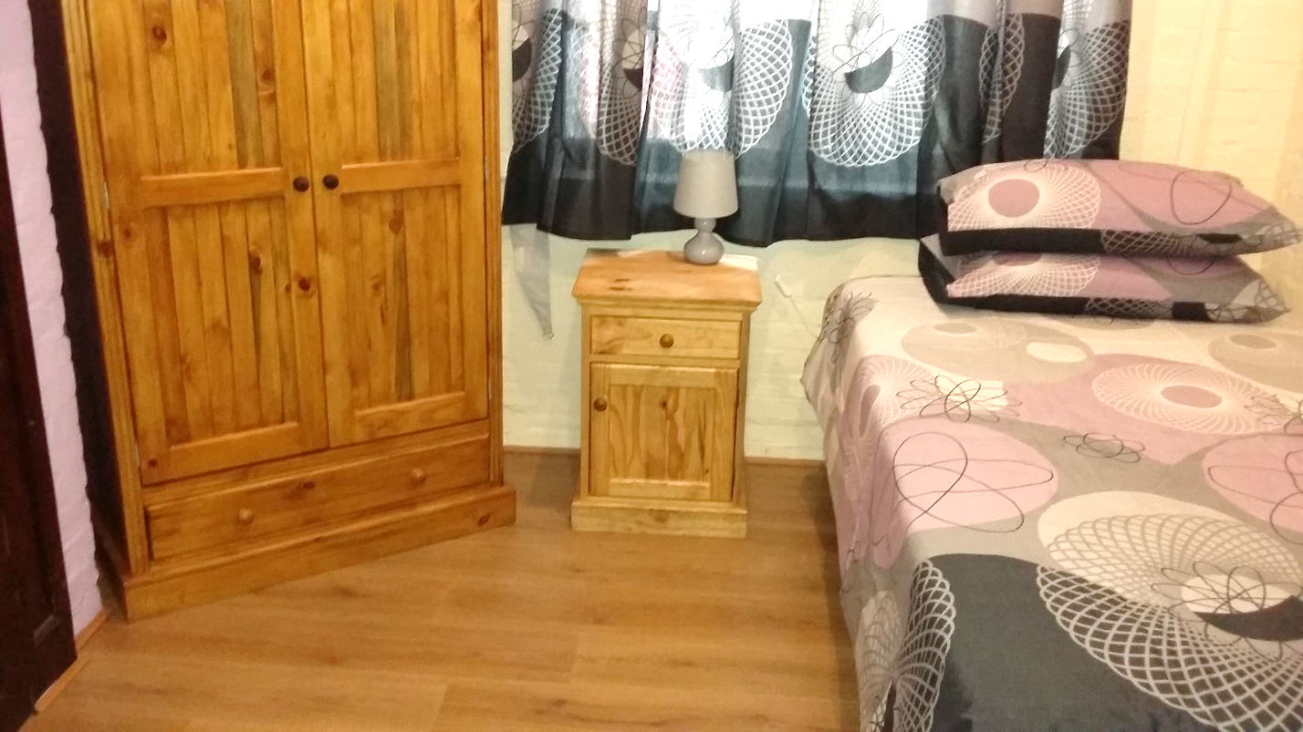
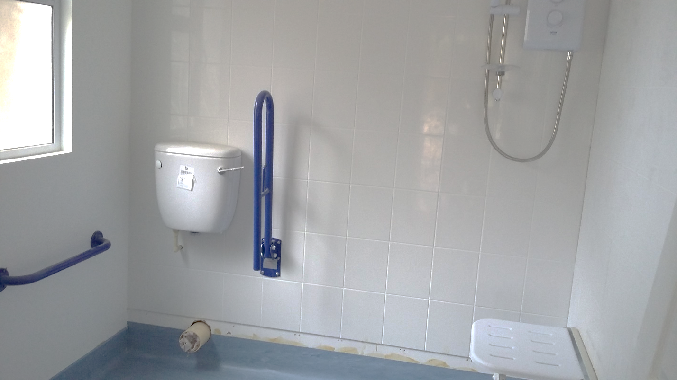
Disabled bedroom completed Disabled bathroom nearing completion

Wooden fencing Exterior of disabled bathroom
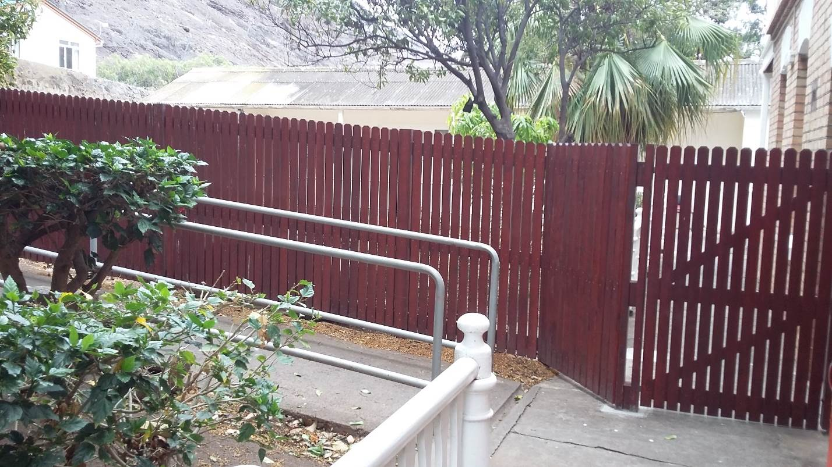
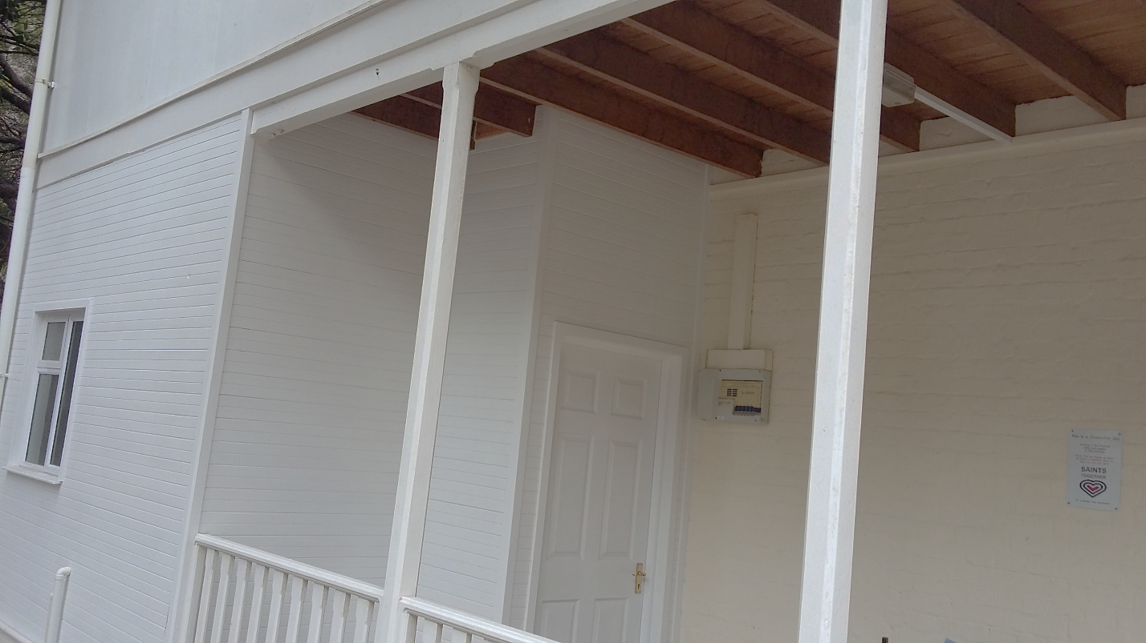

Cleaned garden area
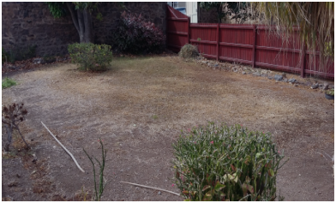

Intercom system bell
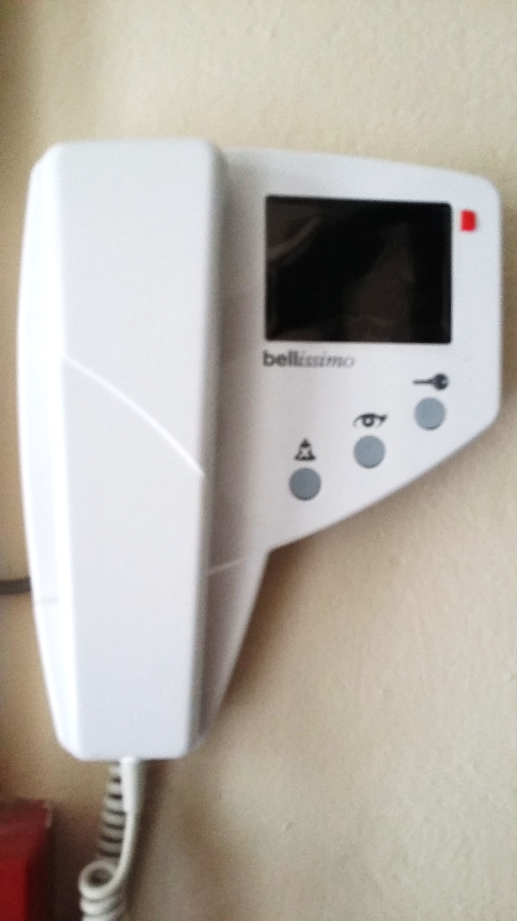

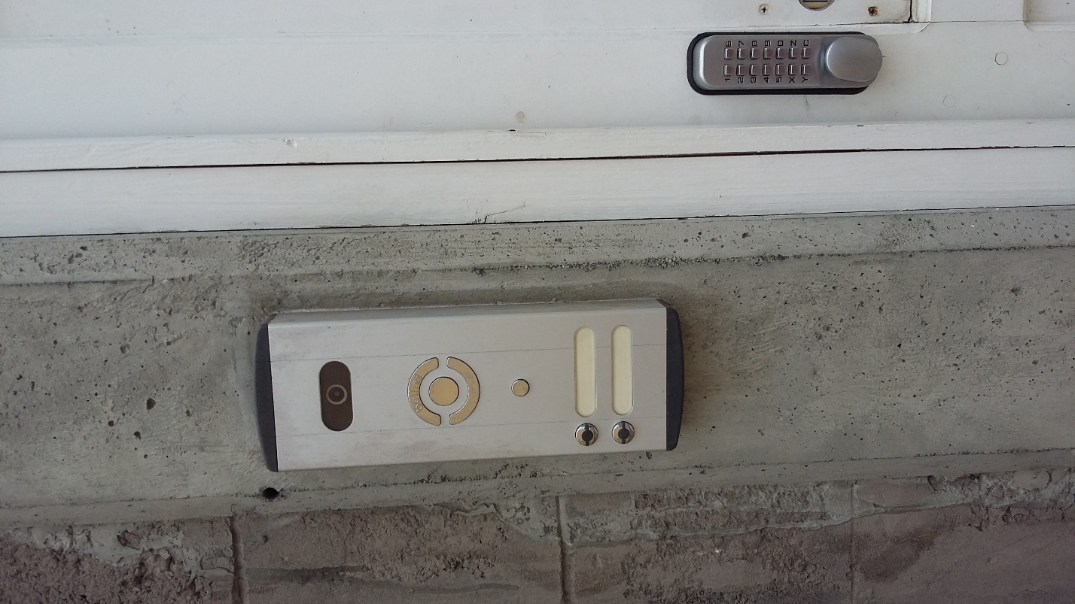

Annex 3: Communication
The below links provide an evidence of communication activities carried out under Output 2.
http://shgintranet/Press%20releases/November%2019/St%20Helena%20Commemorates%2030th%20Anniversary%20Of%20The%20Convention%20On%20The%20Rights%20Of%20The%20Child%20-%2022%20November%202019.pdf
http://shgintranet/Press%20releases/November%2019/White%20Ribbon%20Campaign%20To%20Launch%20On%20St%20Helena%20-%2012%20November%202019.pdf
https://www.sainthelena.gov.sh/2019/11/white-ribbon-campaign-concludes-on-st-helena/
https://www.sainthelena.gov.sh/2019/11/st-helena-commemorates-30th-anniversary-of-the-convention-on-the-rights-of-the-child/
https://www.sainthelena.gov.sh/2019/11/white-ribbon-campaign-to-launch-on-st-helena-2/
https://www.sainthelena.gov.sh/2019/09/st-helena-celebrates-international-youth-day/
https://www.sainthelena.gov.sh/2019/08/international-youth-day-2019/
https://www.sainthelena.gov.sh/2019/07/children-adults-social-care-directorate-recognises-world-elder-abuse-awareness-day/

White Ribbon Campaign:

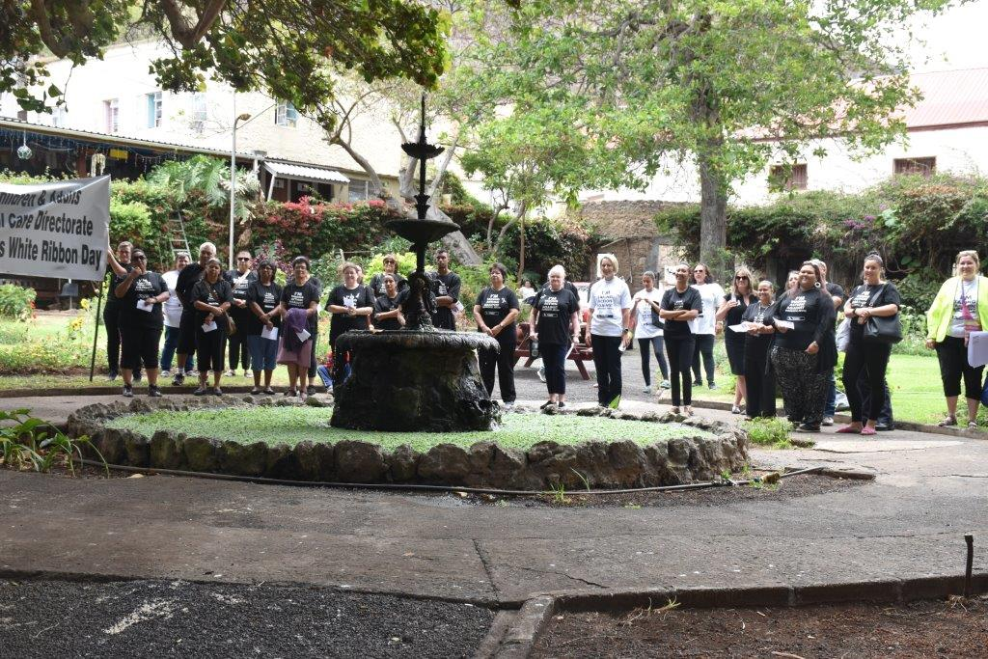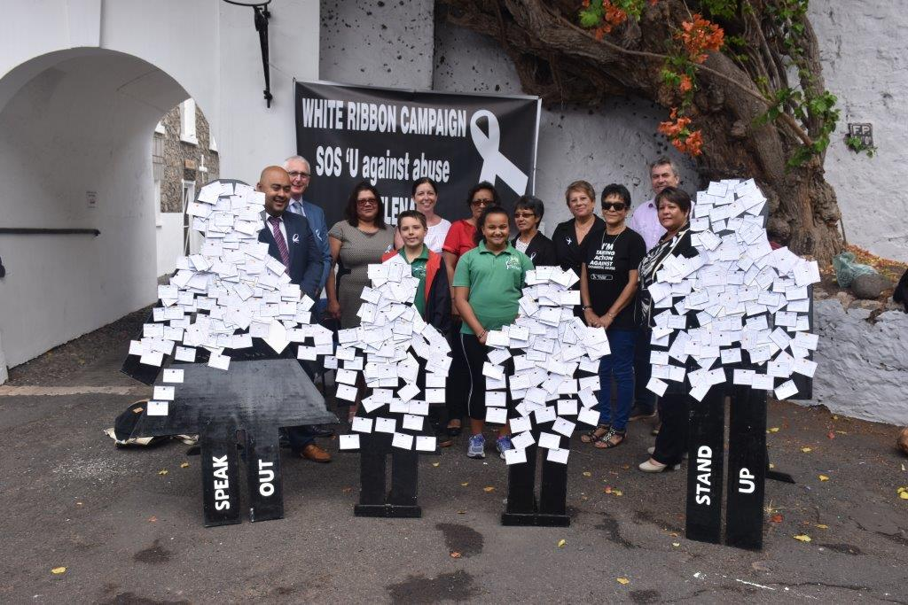

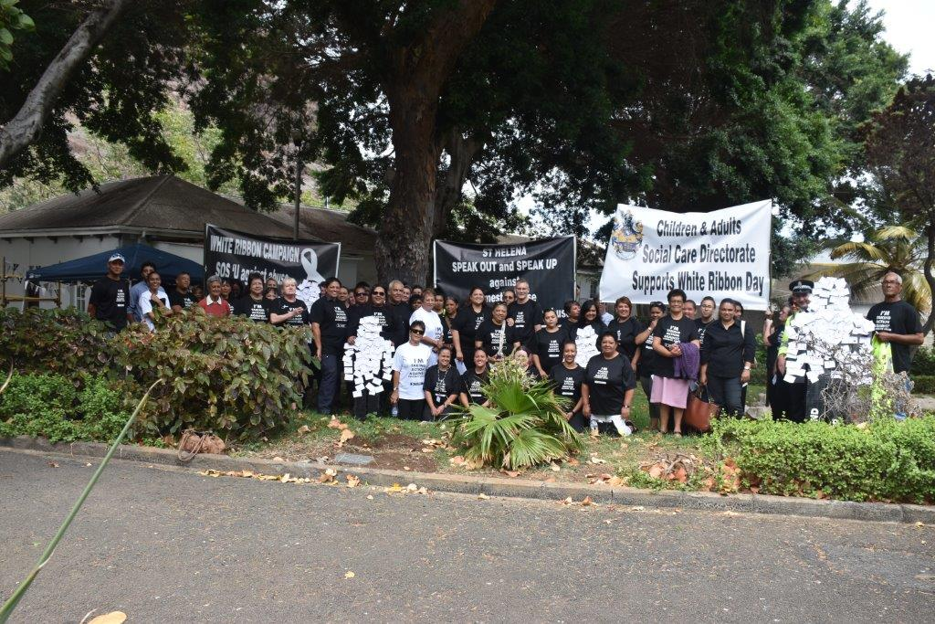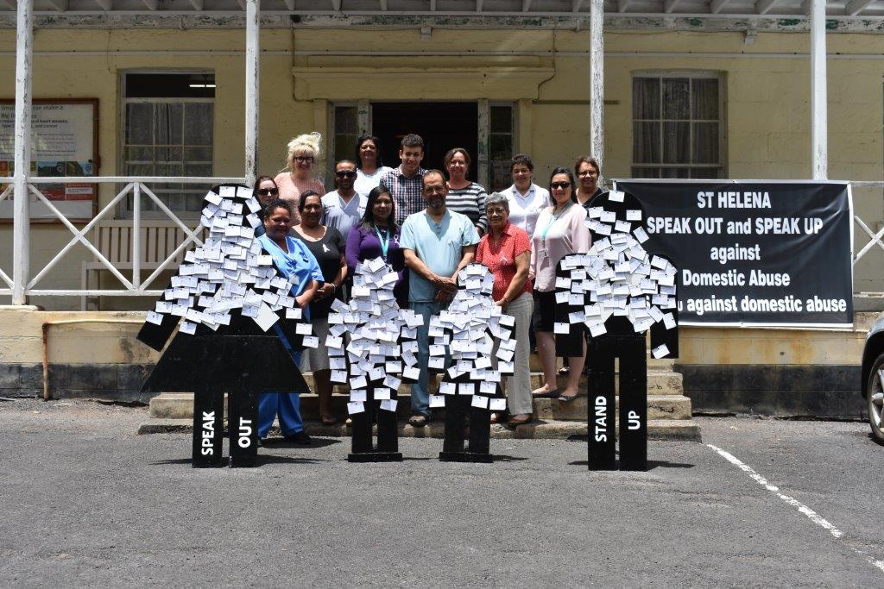

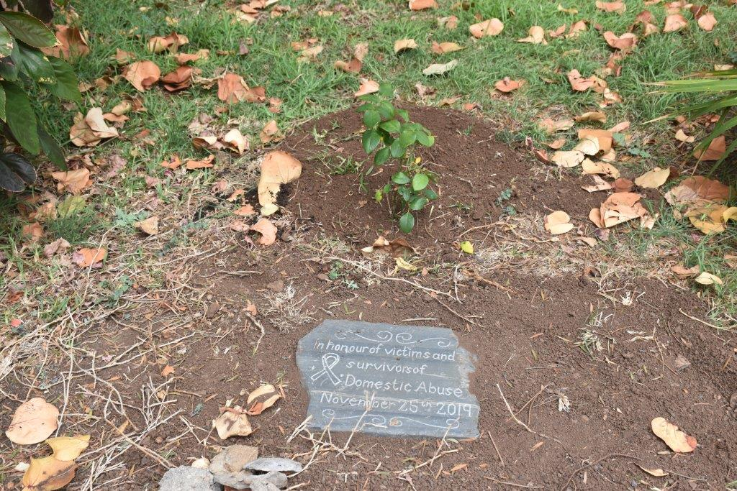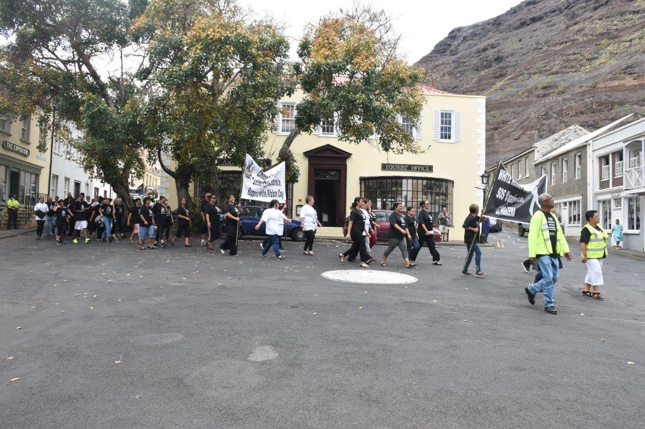
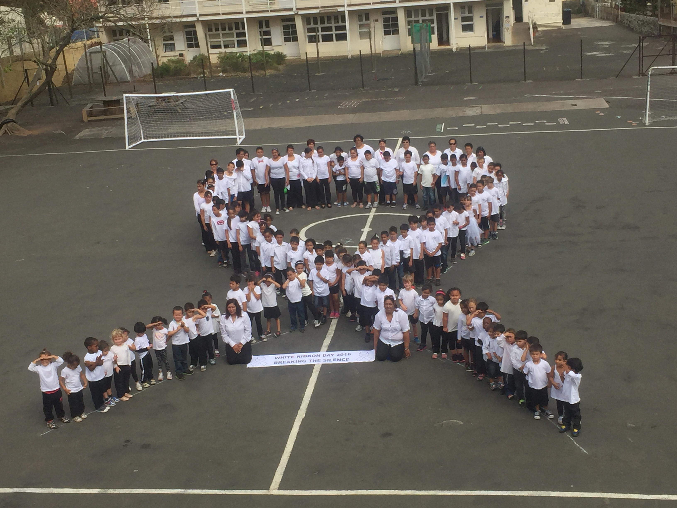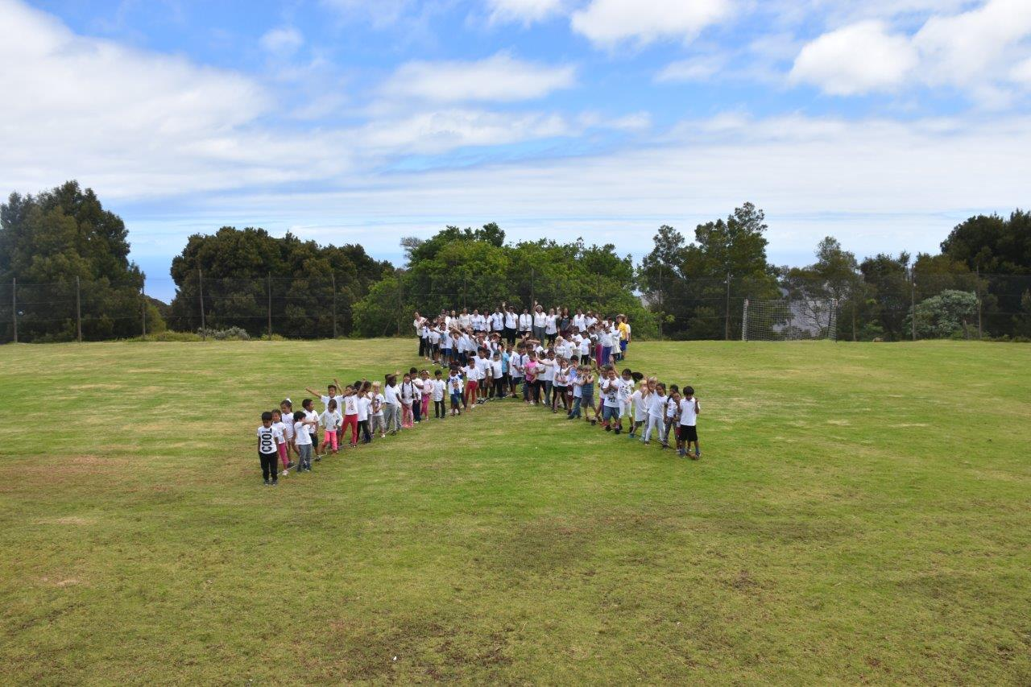

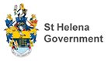

Annex 4: Domestic Violence St Helena Statistics 2019
The police incident and crime reports to provide an understanding of the overall percentages for the past 12 months of 2019
31st Oct 18 – 1st Nov 19
34 Domestic Incidents of which;

Withdrawn at Court 1
Insufficient evidence 5
Non-Crime 18
Harassment Warning 2
Convicted 6
Acquitted 1
Caution 1

Insufficient Evidence includes, victims or witnesses declining to make statements or a review by a prosecutor and not enough to proceeds
Non-Crime means disturbance or domestic incident where there has been no allegations of assaults or a crime (such as verbal arguments and shouting)
The following statistics are based on Domestic Abuse Protection Orders –
Court cases
One was considered in November 2018 but not proceeded with due to Victim Unwillingness.
Granted:
May 2019 – 6 Months – Following conviction assault
June 2019 – 18 Months – Following conviction assault
Oct 2019 – 12 Months – Assault withdrawn, DAPO as alternative



